**DR. B R AMBEDKAR NATIONAL INSTITUTE OF TECHNOLOGY JALANDHAR**





LAB FILE

OF

Computer Graphics

And

Animation

SESSION 2019-2020

**Submitted To: Submitted By:**

Mr. Rahul Aggarwal Ankit Goyal

Assistant Professor 17103011

CSE Department Group-1

**1. Bezier Curve**

#include<iostream.h>

#include<conio.h>

#include<math.h>

#include<graphics.h>

void main()

{

int gd=DETECT,gm;

initgraph(&gd, &gm, "C:\\TURBOC3\\BGI");

int x[4],y[4],i;

double put_x, put_y, t;

cout<<"\n****** Bezier Curver *********"<<endl;

cout<<"Enter four control points of bezier curve: "<<endl;

for(i=0;i<4;i++){

cin>>x[i]>>y[i];

putpixel(x[i], y[i],3);

}

for(t=0.0;t<=1.0;t+=0.001){

put_x=pow(1-t, 3)*x[0]+3*t*pow(1-t,2)*x[1]+3*t*t*(1-t)*x[2]+pow(t,3)*x[3];

put_y=pow(1-t, 3)*y[0]+3*t*pow(1-t,2)*y[1]+3*t*t*(1-t)*y[2]+pow(t,3)*y[3];

putpixel(put_x,put_y,WHITE);

}

getch();

closegraph();

}

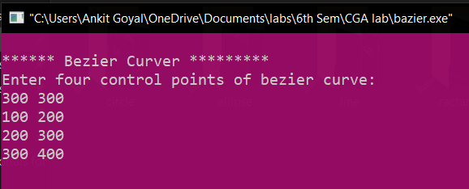

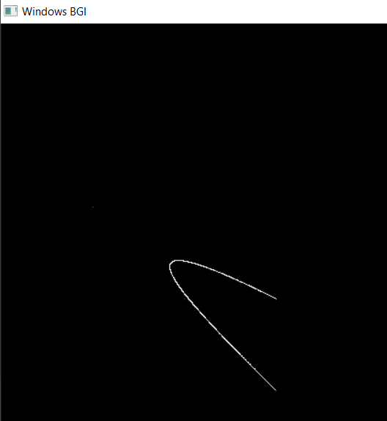

**2. Liang Barsky Algorithm**

#includ#include<iostream.h>

#include<graphics.h>

#include<math.h>

#include<dos.h>

void main()

{

int i,gd=DETECT,gm;

int x1,y1,x2,y2,xmin,xmax,ymin,ymax,xx1,xx2,yy1,yy2,dx,dy;

float t1,t2,p[4],q[4],temp;

x1=120;

y1=120;

x2=300;

y2=300;

xmin=100;

ymin=100;

xmax=250;

ymax=250;

initgraph(&gd, &gm, "C:\\TURBOC3\\BGI");

rectangle(xmin,ymin,xmax,ymax);

dx=x2-x1;

dy=y2-y1;

p[0]=-dx;

p[1]=dx;

p[2]=-dy;

p[3]=dy;

q[0]=x1-xmin;

q[1]=xmax-x1;

q[2]=y1-ymin;

q[3]=ymax-y1;

for(i=0;i<4;i++)

{

if(p[i]==0)

{

cout<<"line is parallel to one of the clipping boundary";

if(q[i]>=0)

{

if(i<2)

{

if(y1<ymin)

{

y1=ymin;

}

if(y2>ymax)

{

y2=ymax;

}

line(x1,y1,x2,y2);

}

if(i>1)

{

if(x1<xmin)

{

x1=xmin;

}

if(x2>xmax)

{

x2=xmax;

}

line(x1,y1,x2,y2);

}

}

}

}

t1=0;

t2=1;

for(i=0;i<4;i++)

{

temp=q[i]/p[i];

if(p[i]<0)

{

if(t1<=temp)

t1=temp;

}

else

{

if(t2>temp)

t2=temp;

}

}

if(t1<t2)

{

xx1 = x1 + t1 * p[1];

xx2 = x1 + t2 * p[1];

yy1 = y1 + t1 * p[3];

yy2 = y1 + t2 * p[3];

line(xx1,yy1,xx2,yy2);

}

delay(5000);

closegraph();

}

